
Sri Lanka Institute of Information Technology

IT3012 : Intelligent Agents – Lab 3
Y3.S1.WD.AI.01.01
Malabe Campus

Student ID - | IT24100140
Student Name - | Prathiban HTP
Module Name - | Intelligent Agents
Module Number - | IT3012
LabSheet Number - | 3
LabSheet Date - | 2026/Aug/5

Task 1
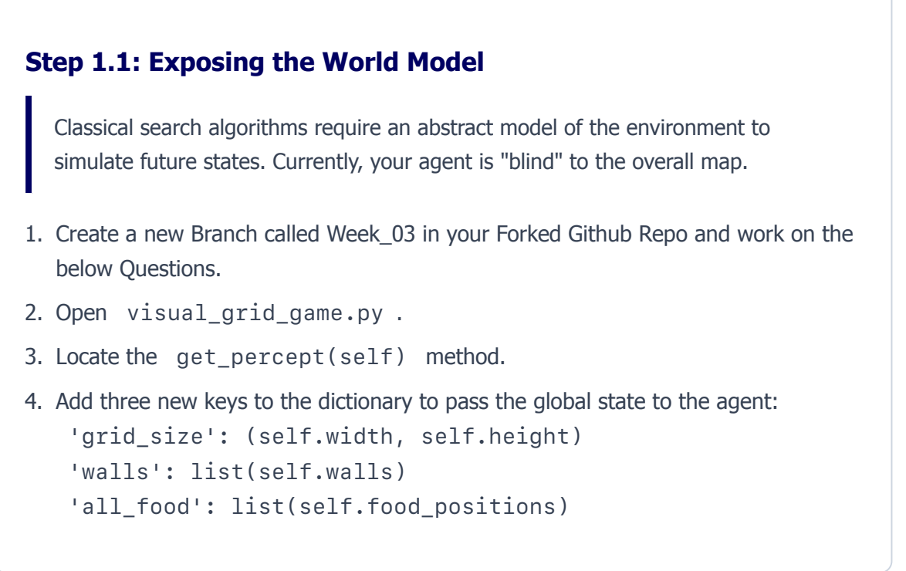
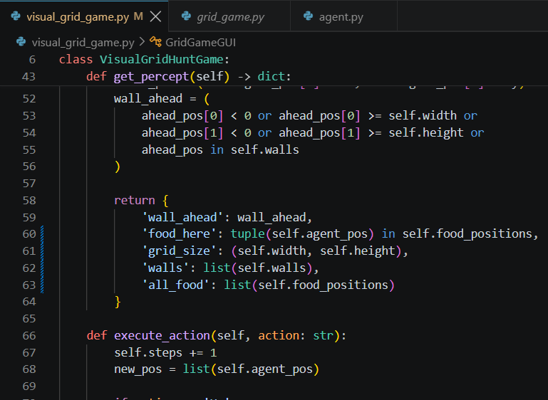

Task 2
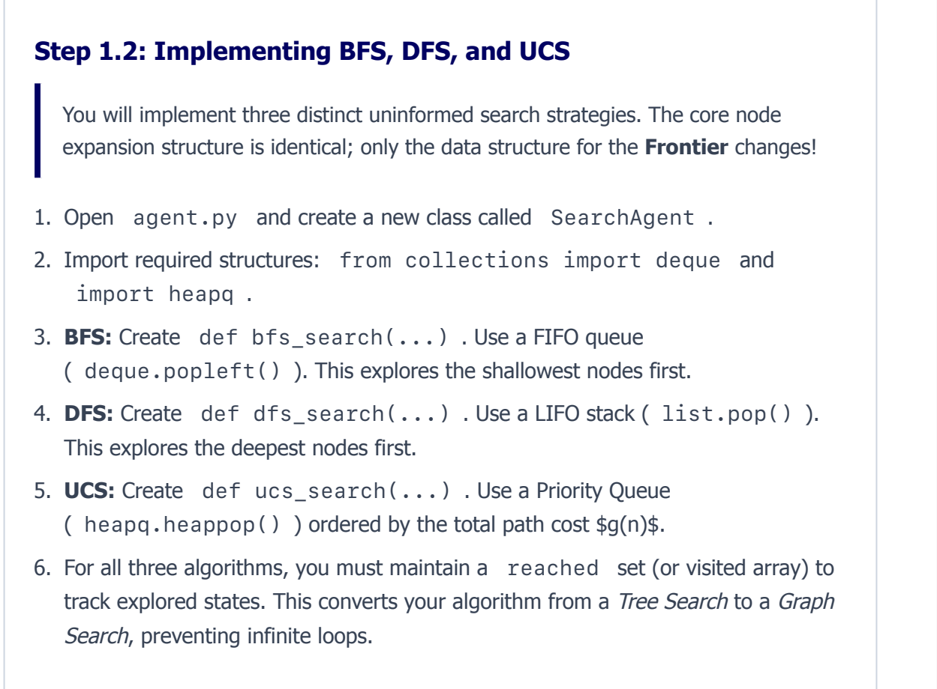
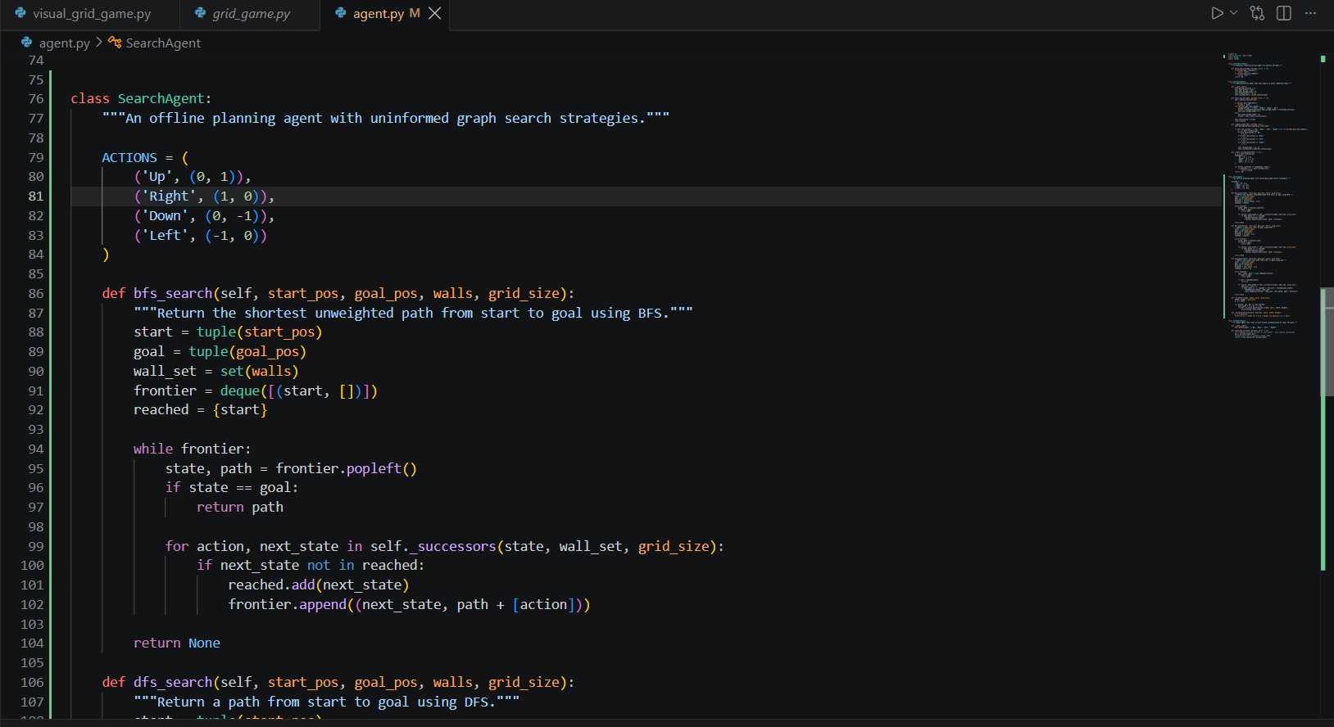

Task 3
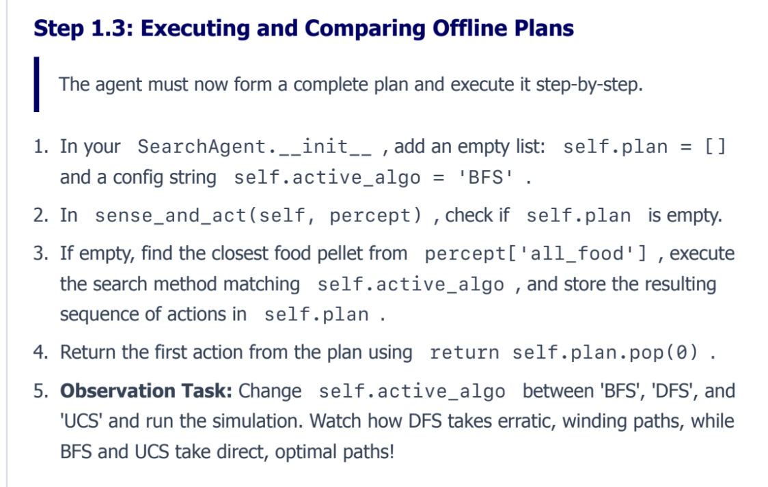
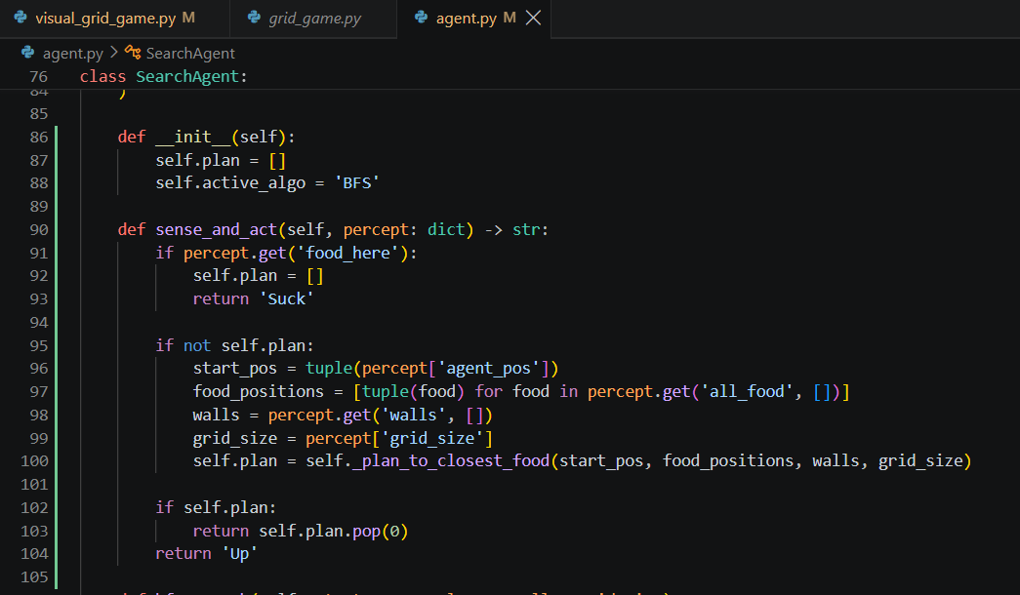

With BFS –
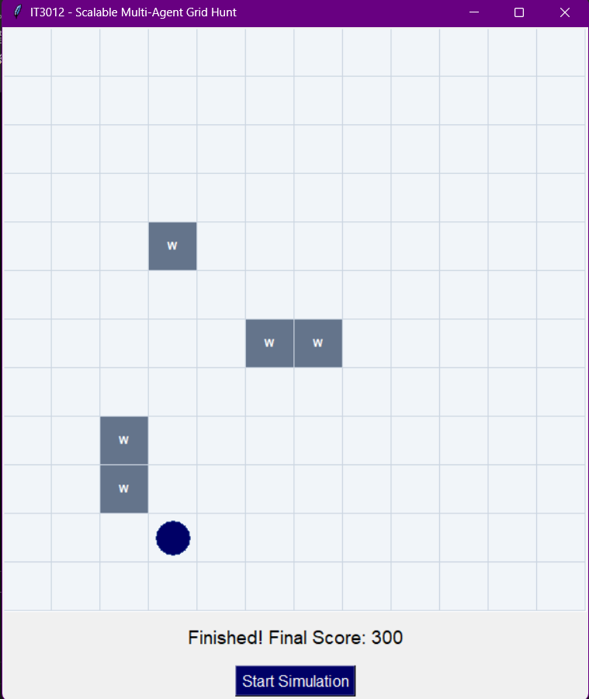
With DFS –
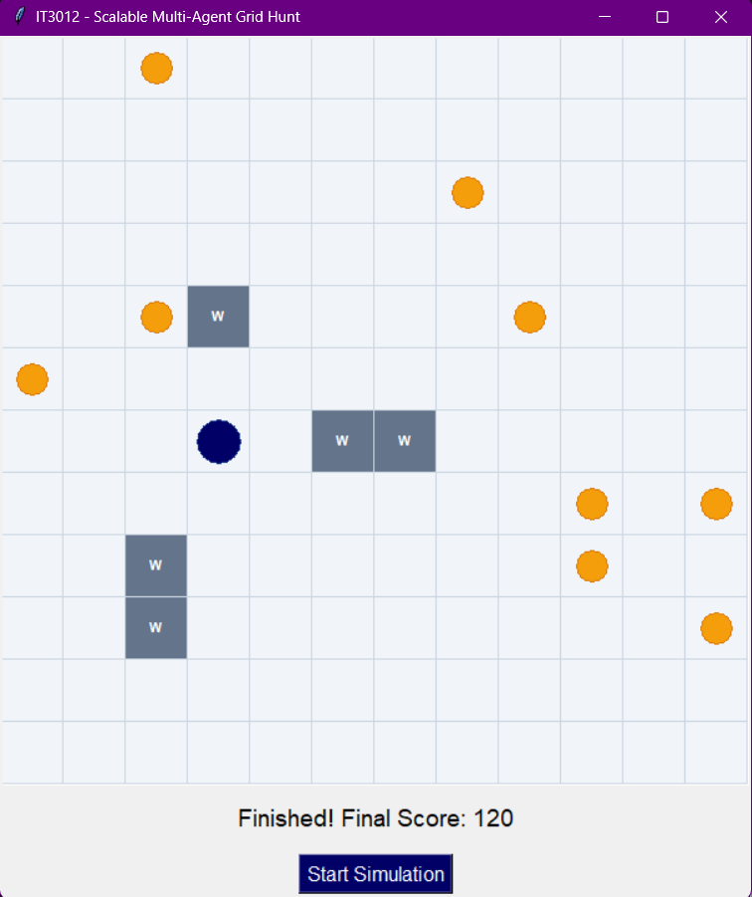

With UCS –
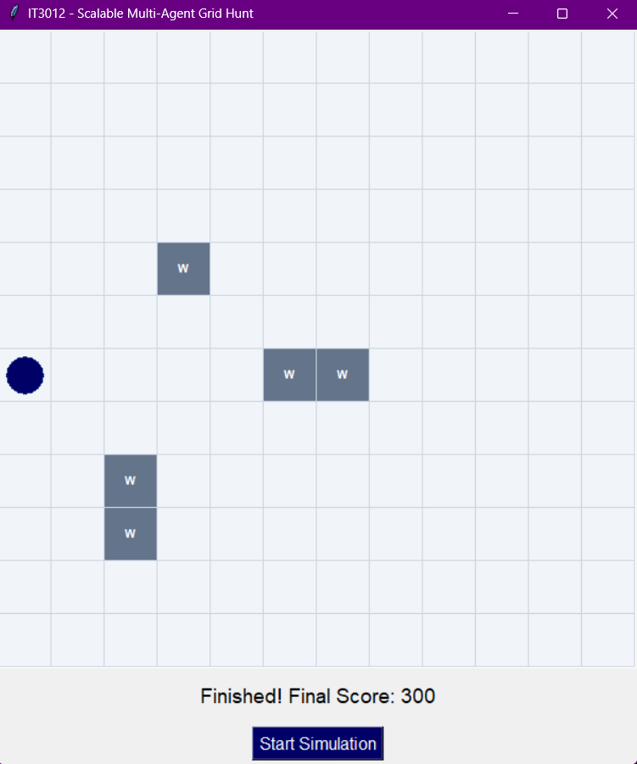

Part 2 Theoretical
1.
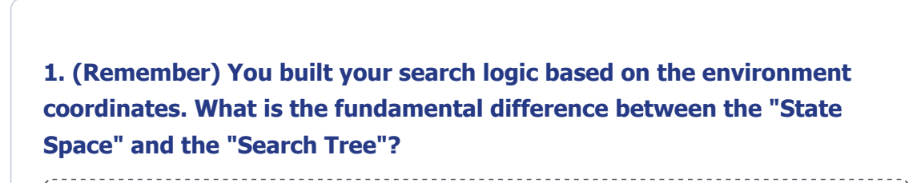
State Space: The complete set of all possible valid states/positions the agent can be in within the environment.

Search Tree: The structure generated by the search algorithm while exploring those states from the initial state.
The same state can appear multiple times in a search tree if it can be reached through different paths, while it represents only one state in the state space.
2.
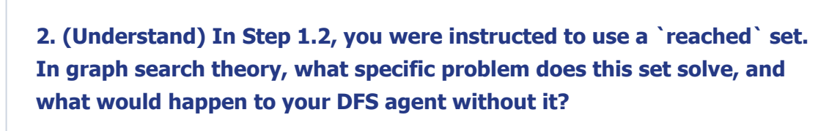
The reached set keeps track of states that have already been visited.
It prevents the agent from: Revisiting the same grid position repeatedly. Creating cycles or infinite loops. Wasting time exploring the same states again.
Without it, DFS could repeatedly move through the same cycle of positions and may never reach the food, especially because DFS explores deeply before trying alternative branches.
3.
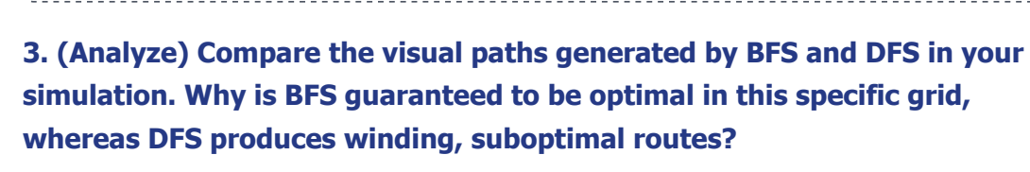
BFS explores nodes level by level, meaning it checks all positions one step away, then two steps away, and so on. Therefore, the first path it finds to the food contains the minimum number of moves, making BFS optimal in this grid.
DFS explores one path as deeply as possible first. It may travel far away from the food before backtracking, causing the winding and longer paths seen in the simulation

4.
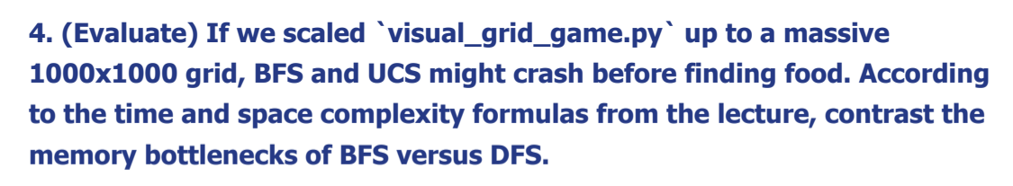
- BFS has a major memory bottleneck because its frontier can grow exponentially with depth.
- DFS uses much less memory, but it may explore very deep or poor paths and does not guarantee the shortest solution.
So DFS is more memory-efficient, while BFS provides better path quality in this equal-cost grid.

